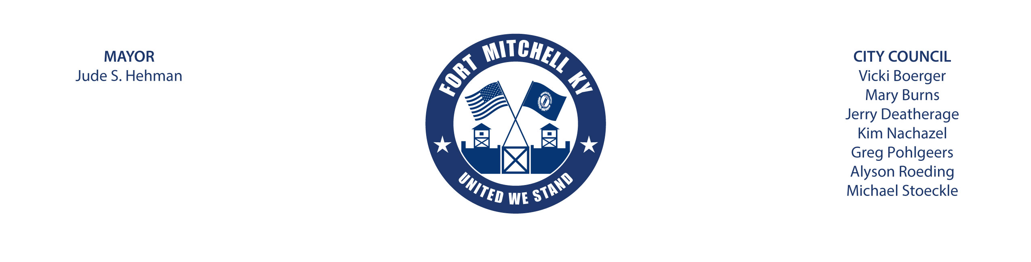

AGENDA
CITY OF FORT MITCHELL
SPECIAL TREE BOARD MEETING
City Council Chamber Room
2355 Dixie Highway, Fort Mitchell, Kentucky 41017
Wednesday, December 15, 2021 at 6:30 p.m.

- Roll call
- Approval of Last Meeting Minutes – Motion Needed
- Review Bylaws and Ordinances
- Nominate Officers-Chair, Vice-Chair and Secretary
- Schedule the Next Meeting
- Review Phase III of Dixie Highway Tree Removal and Planting:
- Review Tree Maintenance and Management Plan
- Adjournment

Reminder: Discussion and actions at the meeting must be limited to the items on this agenda according to Kentucky Revised Statute (KRS 61.823(3)).
Next Meeting: The Tree Board meets as needed. Meeting dates are posted on the website when scheduled.

